BNSI VOMS alarms LLD
Version | Date | Author | Description
0.0 | 16th Nov 2011 | Chris Janes | Original

Description
This doc describes the updates to be made in the BNSI rules files / Impact Policy for the VOMS alarms generated by BNSI nodes.

HLD:
BNSI VOMS alarms should have TTs created after a specified wait time, to allow short term events to clear without TT generation.

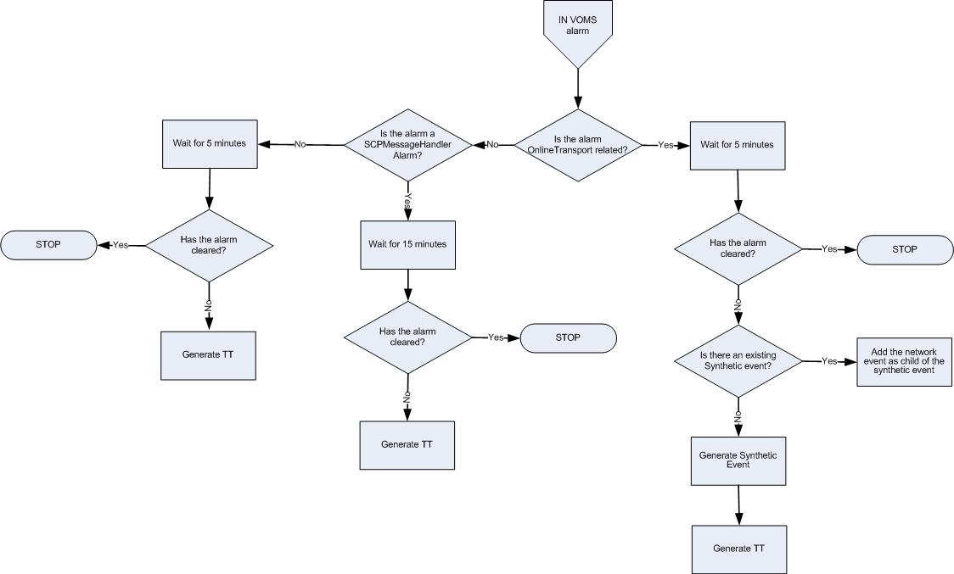

BNSI VOMS alarm handling Flow Chart

Pre-requisite
- Map added into TSRM between EventId “NET_IN_VOMS_001” and classification “VOMS-IN”
- Map added into TSRM between EventId “SYN_IN_VOMS_001” and classification “VOMS-IN”
- The TTHibernate field was added to the ObjectServer schema
- ML_RaiseTT_FirstOccurrence trigger was added in the ObjectServer

Event Filter:
No. | Alarm description | Domain | Field | Value | EventId
1 | BNSI VOMS alarm | BNSI | Summary | OnlineTransport_513:TCP connection id 2202, ip address 10.13.1.129 port 22099 is not available.,  Matching condition:  regmatch(@Summary, "OnlineTransport.* TCP connection id .* is not available") | NET_IN_VOMS_002
2 | BNSI VOMS alarm | BNSI | Summary | OnlineTransport_513:The remote Online-PH subsystem id 4 is not available.,  Matching condition:  regmatch(@Summary, " OnlineTransport.* The remote Online-PH subsystem id .* is not available") | NET_IN_VOMS_002
3 | BNSI VOMS alarm | BNSI | Summary | LoadService: The JMS is not working properly,  Matching condition:  regmatch(@Summary, "LoadService: The JMS is not working properly") | NET_IN_VOMS_001
4 | BNSI VOMS alarm | BNSI | Summary | LoadService: The cluster is not working properly,  Matching condition:  regmatch(@Summary, "LoadService: The cluster is not working properly") | NET_IN_VOMS_001
5 | BNSI VOMS alarm | BNSI | Summary | SCPMessageHandler: SCP Message Handler: Too many connections on port 22013. Refused to open new connection to 10.12.4.35/10.12.4.35,  Matching condition:  regmatch(@Summary, "SCPMessageHandler: SCP Message Handler: Too many connections on port") | NET_IN_VOMS_001

Data Types:
Name | Contents
OS_Status | Object Server

Logic:

BNSI VOMS alarm received
- Assign EventID and Domain for relevant network alarms as defined in event filter section.
- Alarms 1 and 2 are processed by the ML_INVOMS Impact Policy
- For alarms 3 – 4 set TTHibernate=300 (seconds)
- For alarm 5 set TTHibernate=900 (seconds)

If not cleared after TTHibernate time, raise a TT for the alarm (for alarms 3 -5)
- The ML_RaiseTT_FirstOccurrence trigger checks for TTHibernate>0, Severity>0 and CurrentTime-FirstOccurrence>=TTHibernate and sets the alarm for ticketing (@LogTicket=1).

THE STEPS BELOW APPLY ONLY FOR ALARMS 1 & 2.
THEY ARE TO BE PERFORMED IN THE ML_INVOMS IMPACT POLICY.

Wait for 5 min / Has the alarm cleared?
- Hard-code a sleep period of 5 minutes and then check if the alarm still exists and is not cleared (Severity>0)

Is there an existing BNSI VOMS synthetic event for the NE?
- Check for an alarm with @EventId=’SYN_IN_VOMS_001’
- If found, add the current network event as a child of the existing event via the journal. Set the @SyntheticServerSerial for the network event equal to the synthetic event @ServerSerial.
- Update the severity of the synthetic event based on the severity of the most recently added network event.

If not found, generate new synthetic BNSI VOMS event
- If no existing synthetic event found, create a new synthetic event with the current event added as a child (journal entry). Populate @SyntheticServerSerial of the network event with serial of the synthetic event.

Field Name | Value
Node | @Node
NodeAlias | @NodeAlias
Summary | BNSI VOMS OnlineTransport
AlertGroup | @AlertGroup
Agent | Netcool Impact
Manager | Netcool Impact
Severity | 5
Type | 1
LogTicket | 1
ImpactFlag | 6
MaintFlag | @MaintFlag
EventId | SYN_IN_VOMS_001
Class | 200042
Site | @Site
SiteCode | @SiteCode
Identifier | Node + Summary + Type + EventId + <@LastOccurrence from network event>
FirstOccurrence/ LastOccurrence | getdate()
Domain | @Domain
Region | @Region
ManCity | @ManCity
CovCity | @CovCity
OutsourceContractor | @OutsourceContractor
BusImportance | @ BusImportance
Vendor | @Vendor
BSC_Name | @BSC_Name
BTS_Name | @BTS_Name
AdvCorrServerSerial | @Serial
OmcEms | @OmcEms

Resolution of events
EventId | Resolution mechanism
NET_IN_VOMS_001 | Clearance of the network event is managed by its resolution event.
NET_IN_VOMS_002 | Clearance of the network event is managed by its resolution event.  NOTE: the EventId is to be added in the ML_ClearSyntheticEvent policy, to ensure the clearance of its corresponding synthetic event when all the child events are cleared.
SYN_IN_VOMS_001 | Clearance of the synthetic event is managed by the ML_ClearSyntheticEvent policy when all the child network events are cleared and 60 minutes passed from the resolution of the last network event.

